Old Wolf Charity Bike Show
Windsor & District MAG

£75 for best in show and £25 for runner up
(donated by Sid Morams)

Charity Auction
Patch sewing service

Top Quality Rally Burgers
Stalls
Live band

£2 for daytime or
£4 for day and evening.
Camping available from Friday evening

14th - 15th Sept 2007
Saturday: 12 noon til late
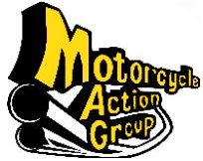

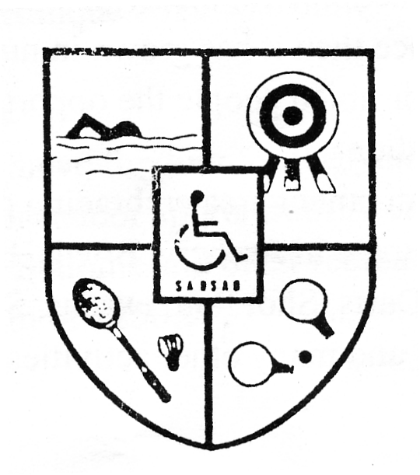
For more details,
phone Peter on 07971 719517
e-mail show@wadmag.org.uk
or visit www.wadmag.org.uk

Slough
And
District
Sports
Association
for Disabled
(SADSAD)

Slough

M40 J.2

M4 J.6

A4
The SADSAD club 225 - 227 Northern road, Slough.

A355
Texaco Garage

