Old Wolf Charity Bike Show
Windsor & District MAG

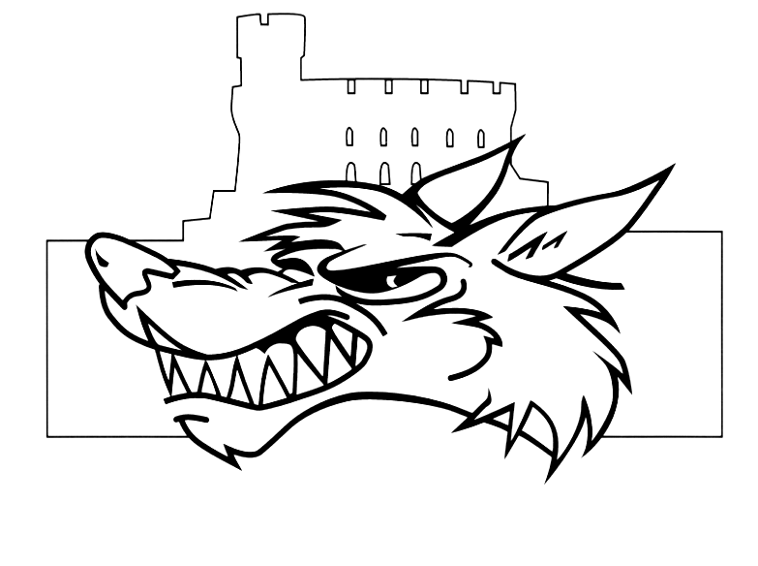
£75 for best in show and £25 for runner up
(donated by Sid Morams)

Charity Auction

Live Band

Top Quality BBQ

Bouncy Castle
Stalls

£2 for daytime or
£4 for day and evening.
Camping available from Friday evening

28th - 29th July 2006
12pm til late
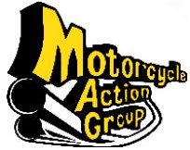

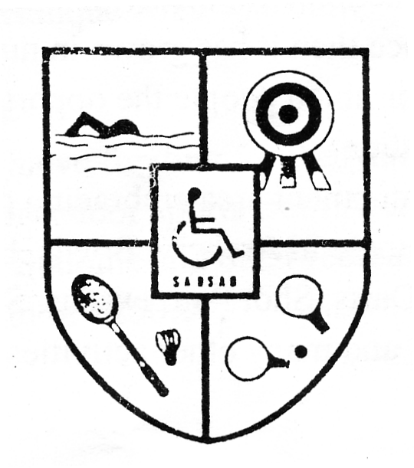
For more details,
phone Rich on 01753 674145,
or 07949 960 999,
e-mail show@wadmag.org.uk
or visit www.wadmag.org.uk

Slough
And
District
Sports
Association
for Disabled
(SADSAD)

Slough

M40 J.2

M4 J.6

A4
The SADSAD club 225 - 227 Northern road, Slough.

A355
Texaco Garage

