Old Wolf Bike Show
Windsor & District MAG

Charity Auction

Live Band

Top Quality Rally Burgers
£75 for best bike in show

Bouncy Castle
Stalls

£2 for daytime or
£4 for day and evening.
Camping available from Friday evening

Slough
M40 J.2
M4 J.6
A4
The SADSAD club 225 - 227 Northern road, Slough.

A355
Texaco Garage
9th - 10th September 2005
12pm til late
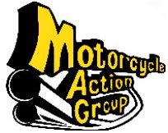

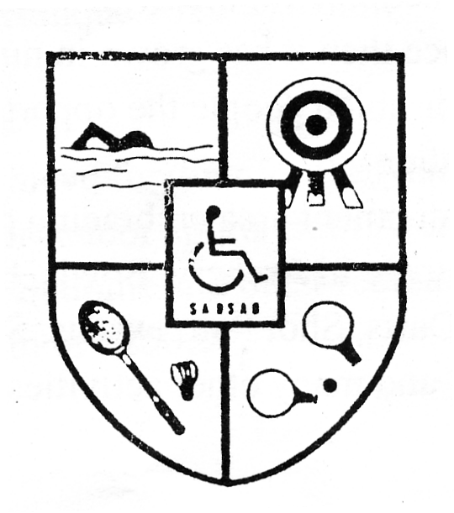
For more details,
phone Jo on 07968 477747,
Rich on 07949 960 999,
e-mail show@wadmag.org.uk
or visit www.wadmag.org.uk

Slough
And
District
Sports
Association
for Disabled
(SADSAD)

